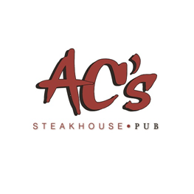

Thank you for joining us for our annual Mother’s Day celebration. Please be advised that by booking this reservation you are agreeing to our Mother’s Day reservation terms and conditions.

- Please contact our restaurant directly for groups of six (6) or more for large table availability.
- Our special Easter Brunch menu will be the only menu available for adults. This menu is available for viewing on our website. Our Kid's Menu will be available for guests 12 and under.
- 20% Gratuity will be automatically added to all checks.
- A non-refundable deposit of $10 per person is required for making a reservation. This deposit will be credited towards your bill for all guests that show up for their reservation.
- Please notate any high chair request in the “special requests” section and these must be included in the guest total for the reservation. High chairs are limited so it is important to communicate this request when booking your reservation.
- Reservations are considered cancelled / no show 15 minutes after the scheduled reservation time.
- We will do our best to grant all specific tables or table location requests but these requests are not guaranteed.
- If you are unable to sit at a high-top table or a booth, please communicate this restriction in the "special requests" section when making the reservation. We do not allow booster seats or highchairs at high-top tables or booths. If your request creates an issue with table availability, you will be notified in advance.

Thank you.

